ITC Assignment 02

**Taaha Hussain Khan**

Roll No: **L1F21BSCS0917**

Section:

**A21**

**Question 01**

**Write the pseudocode of the following code by hand.**

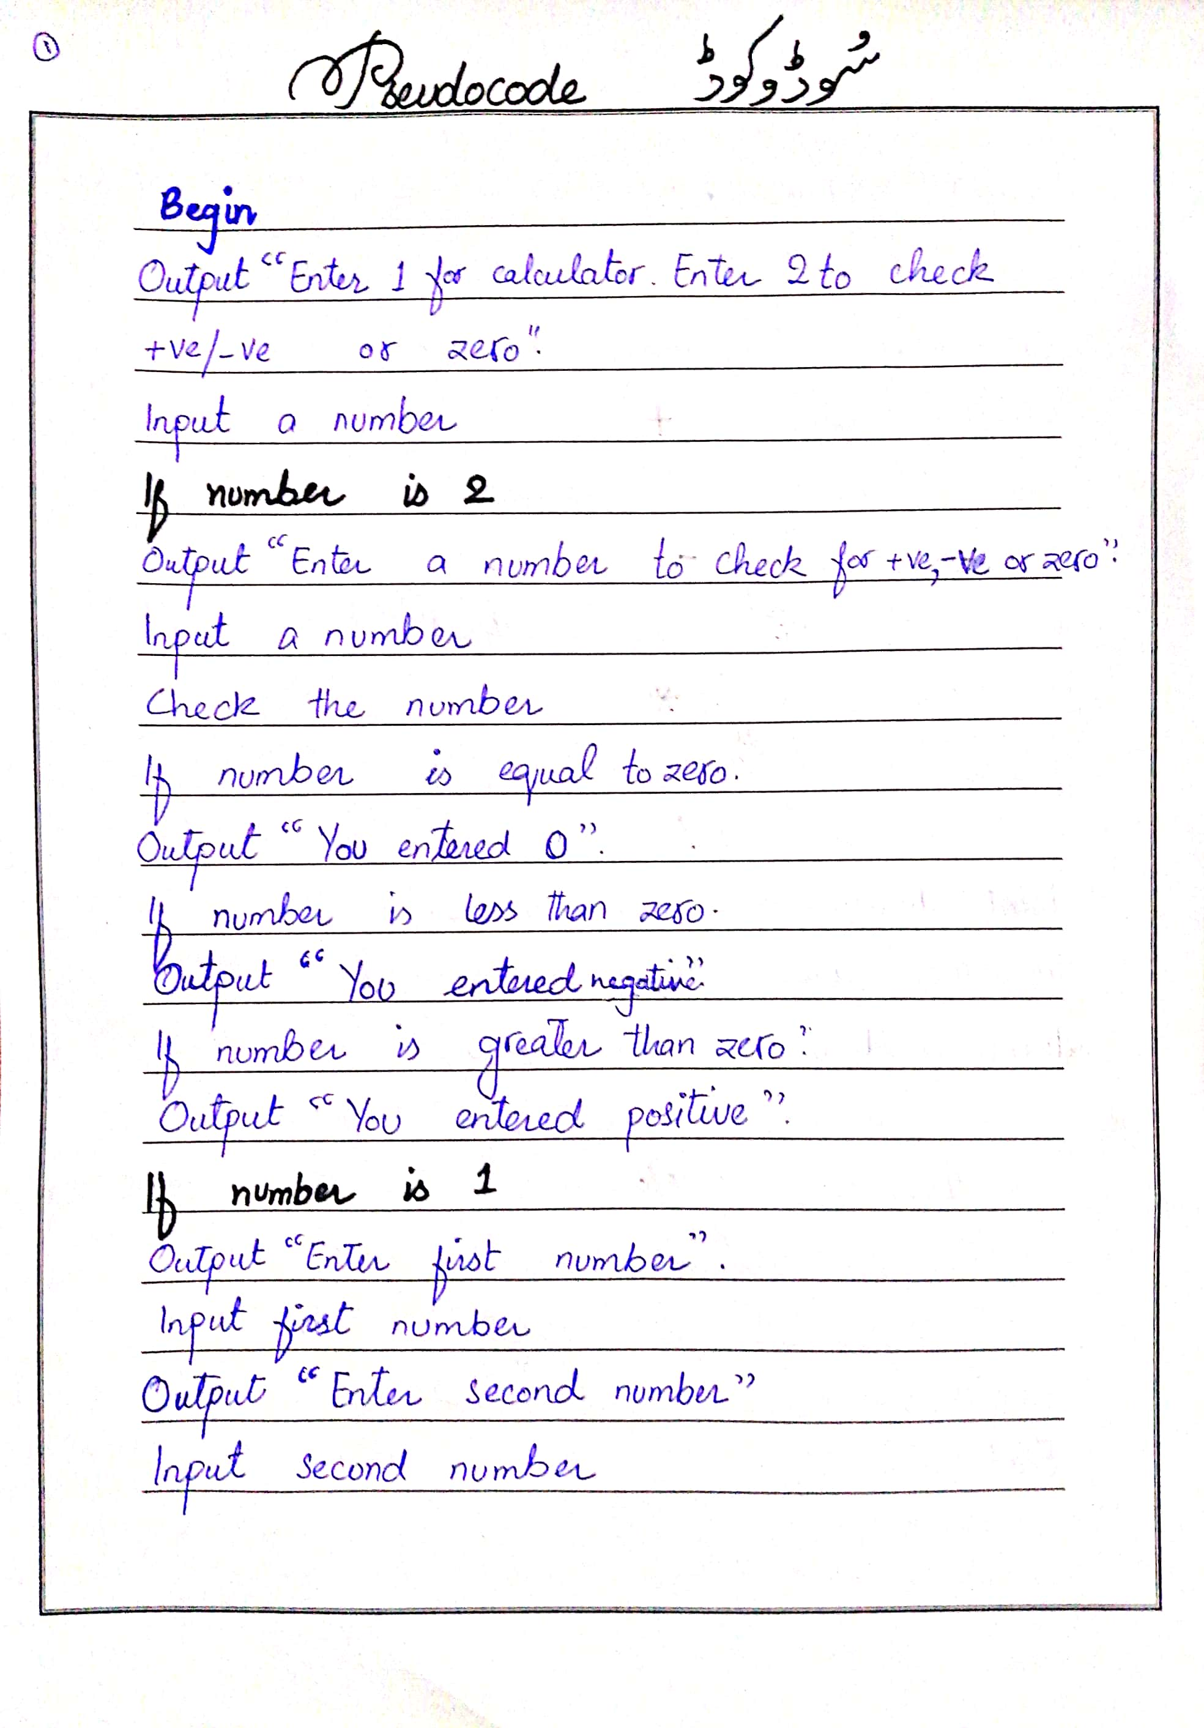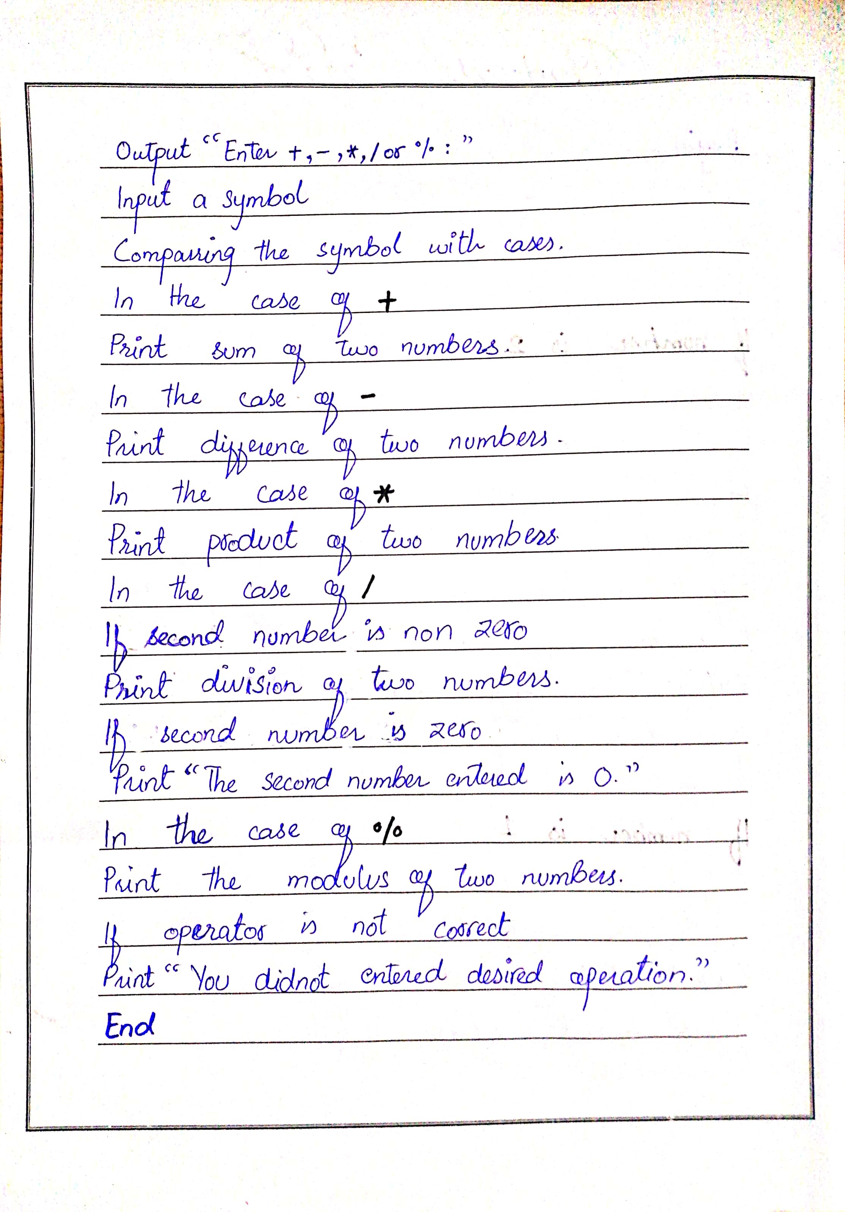

**Question 02**

**Draw the flowchart of the following code by hand.**

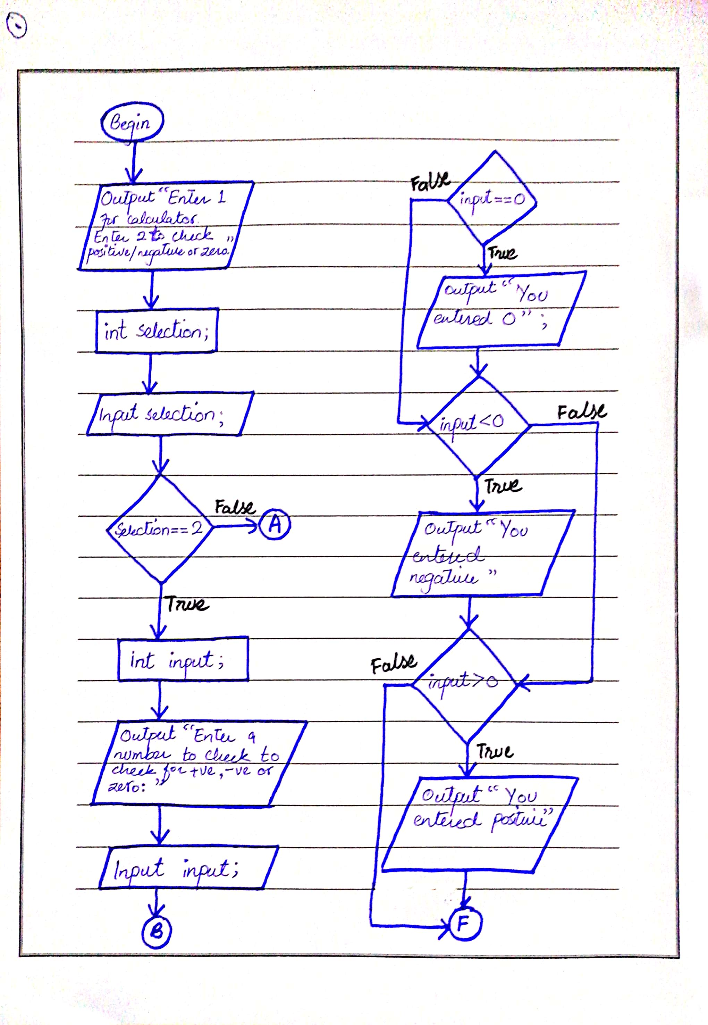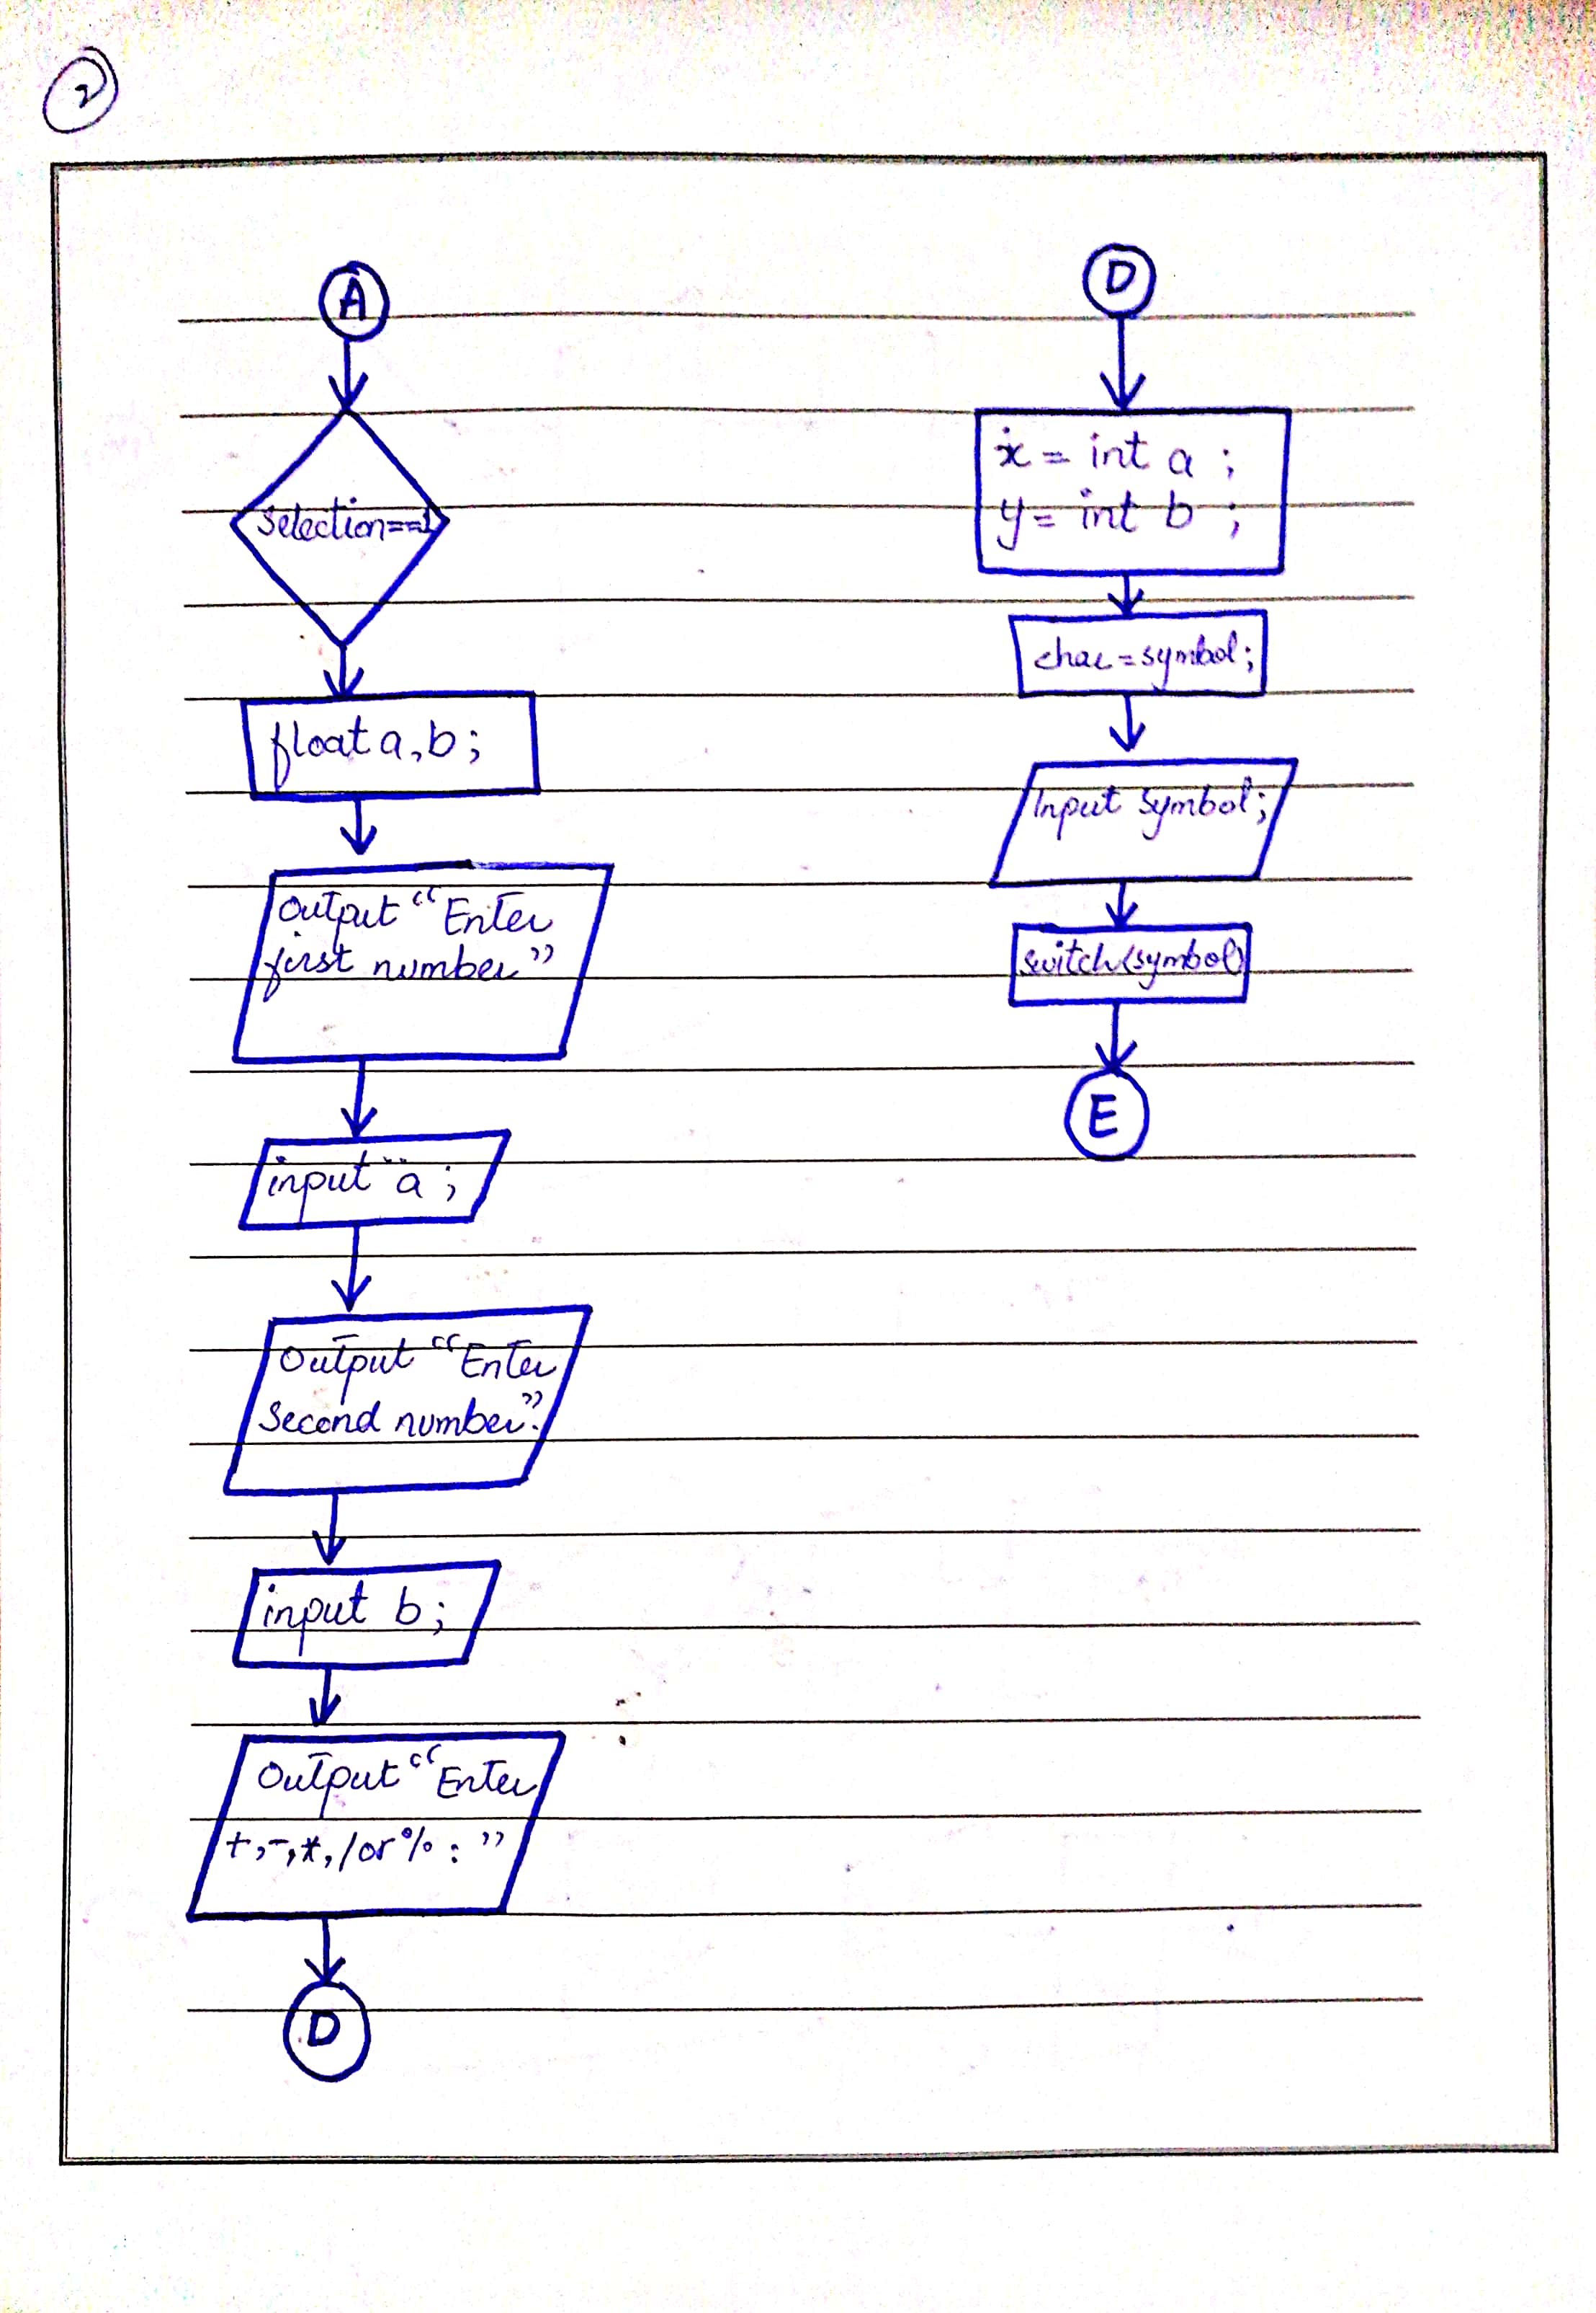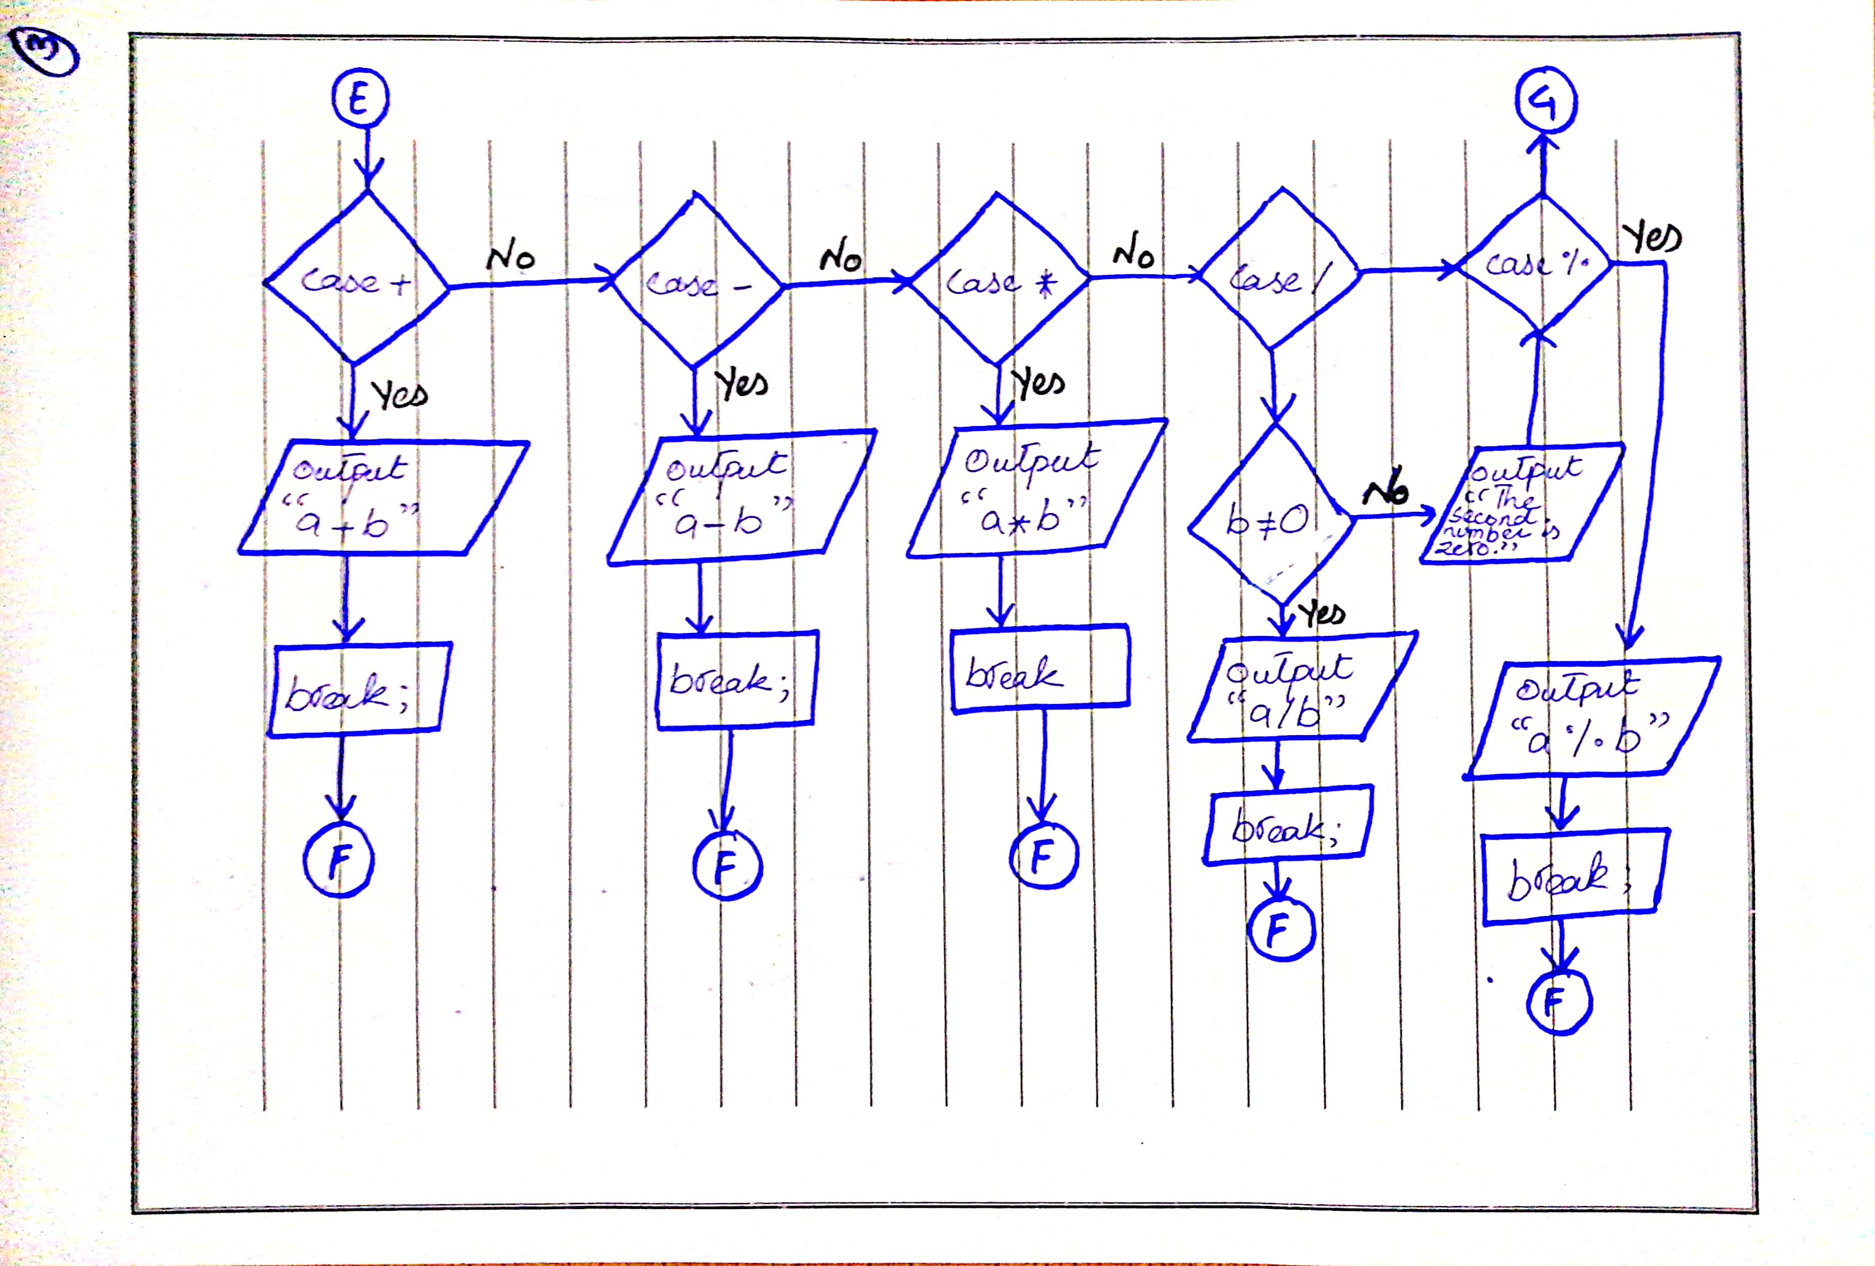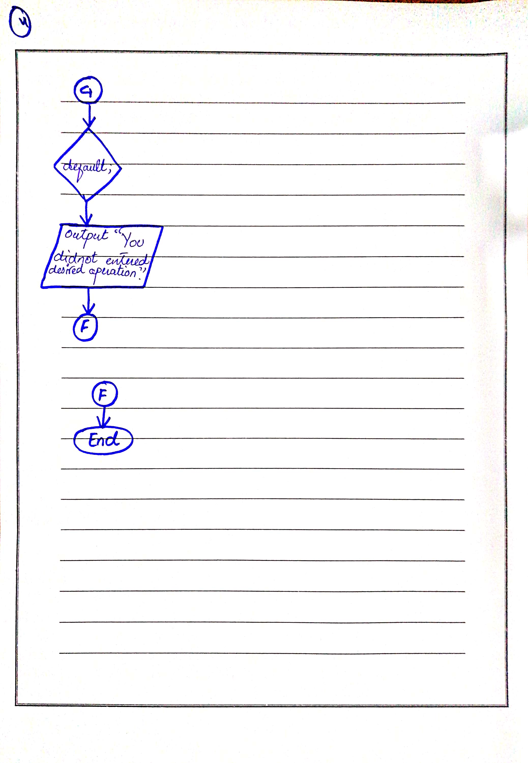

**Question 03**

1. **For variable named *selection*, give any input other than 1 and 2.**

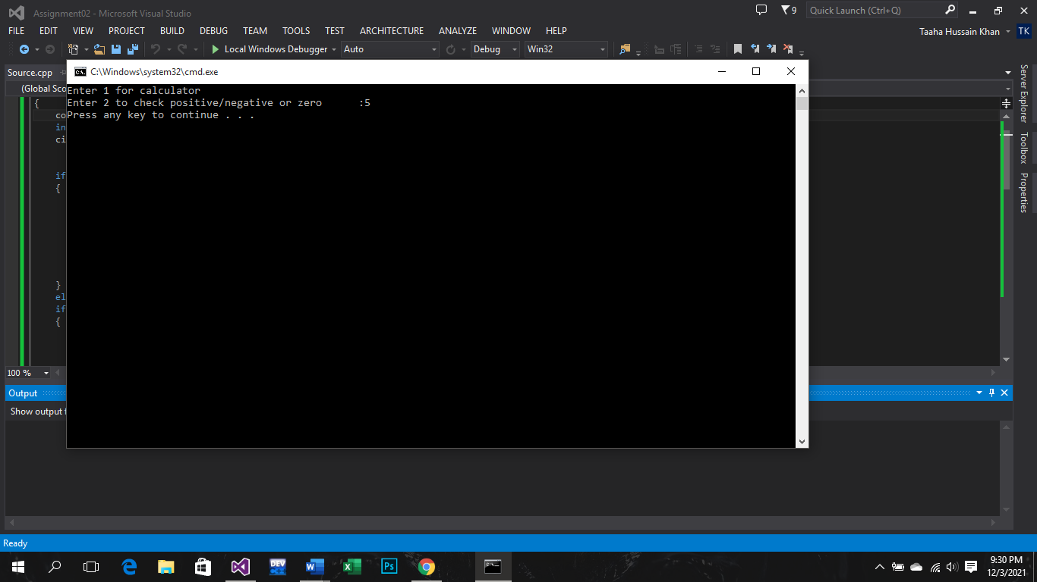

1. **For variable named *selection*, give input 2, than for variable named *input*, give input last 4 digits of your roll number (e.g: 0539).**

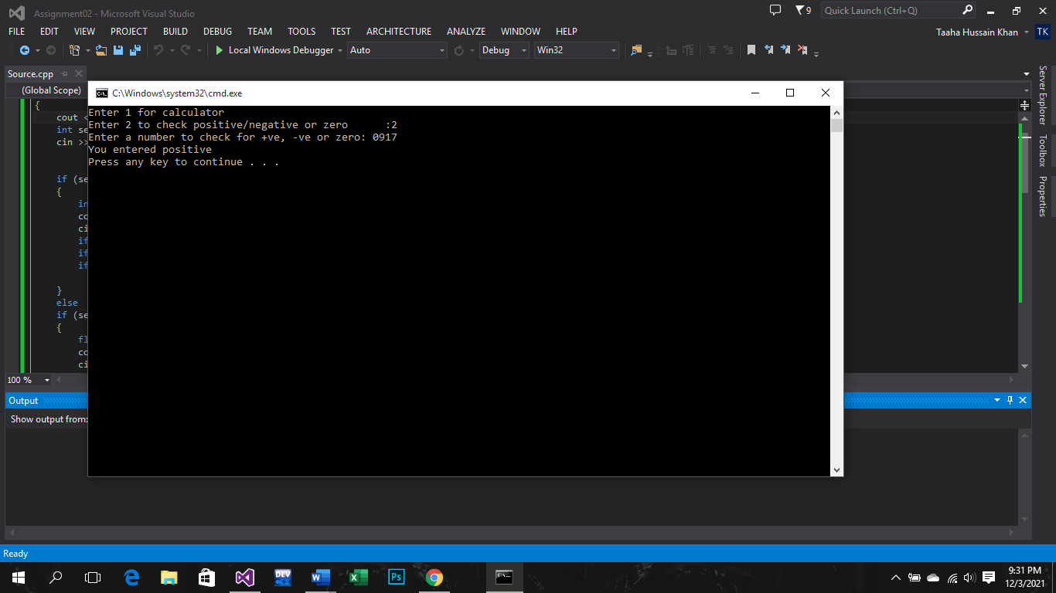

1. **For variable named *selection*, give input 2, than for variable named *input*, give input 0.**

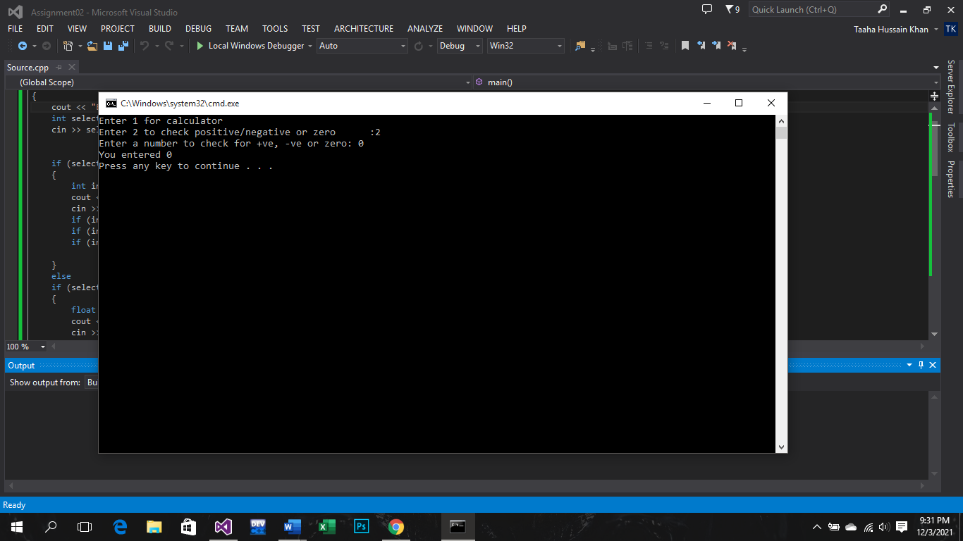

1. **For variable named *selection*, give input 2, than for variable named *input*, give input -1.**

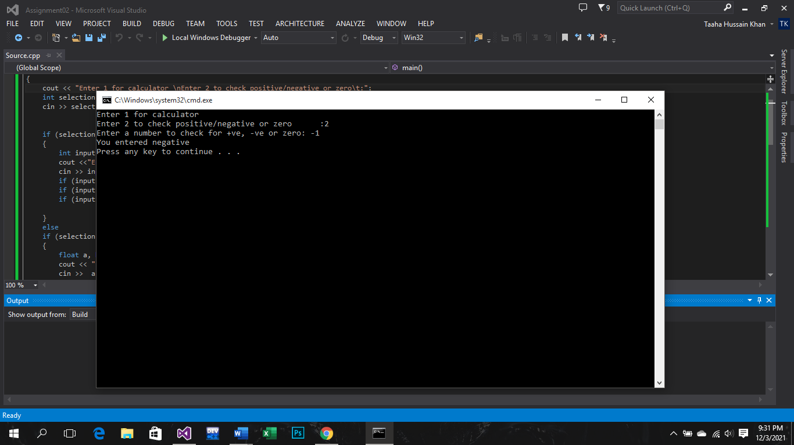

1. **For variable named *selection*, give input 1, than for variables named *a* and *b*, give any decimal value input. Than for variable named *symbol*, give input +.**

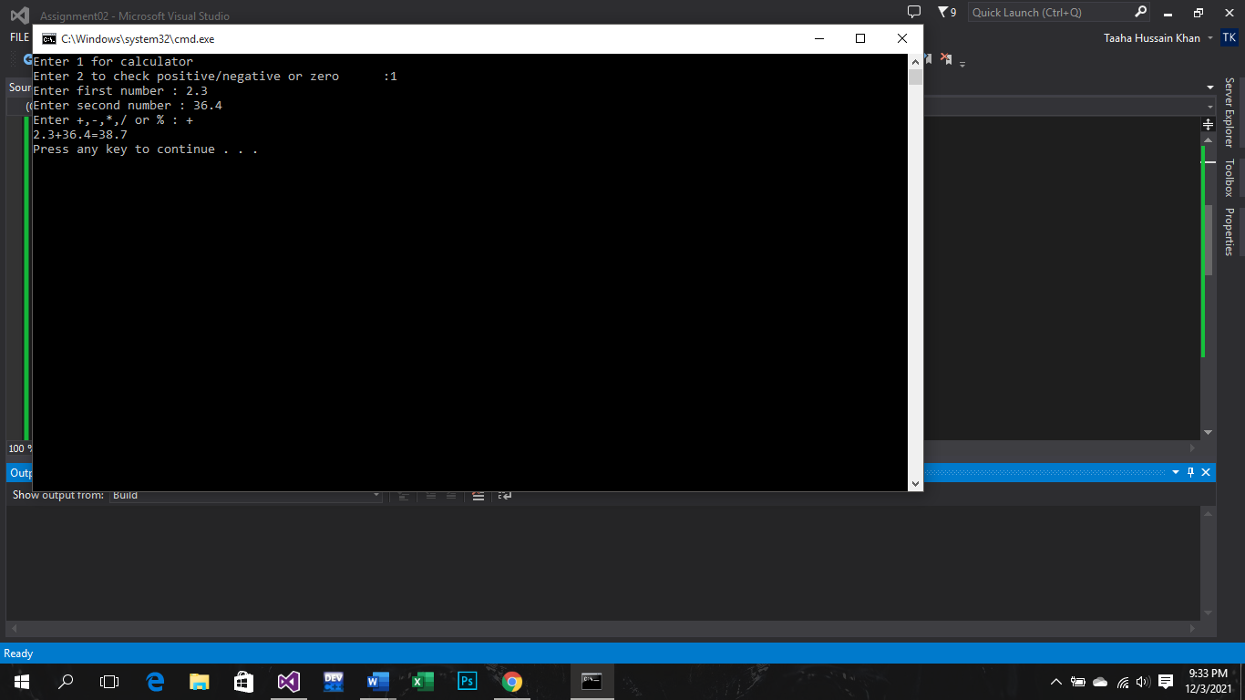

1. **For variable named *selection*, give input 1, than for variables named *a* and *b*, give any decimal value input. Than for variable named *symbol*, give input -.**

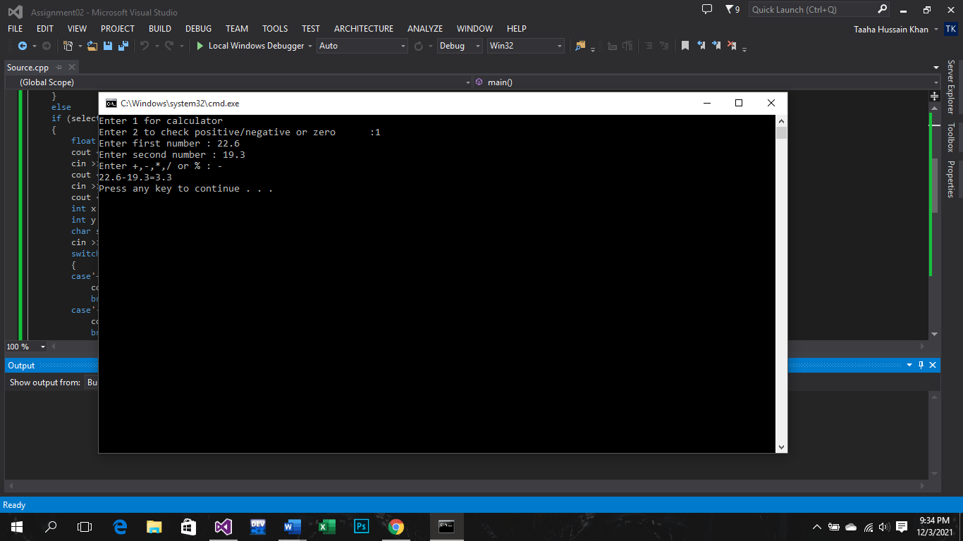

1. **For variable named *selection*, give input 1, than for variables named *a* and *b*, give any decimal value input. Than for variable named *symbol*, give input *.**

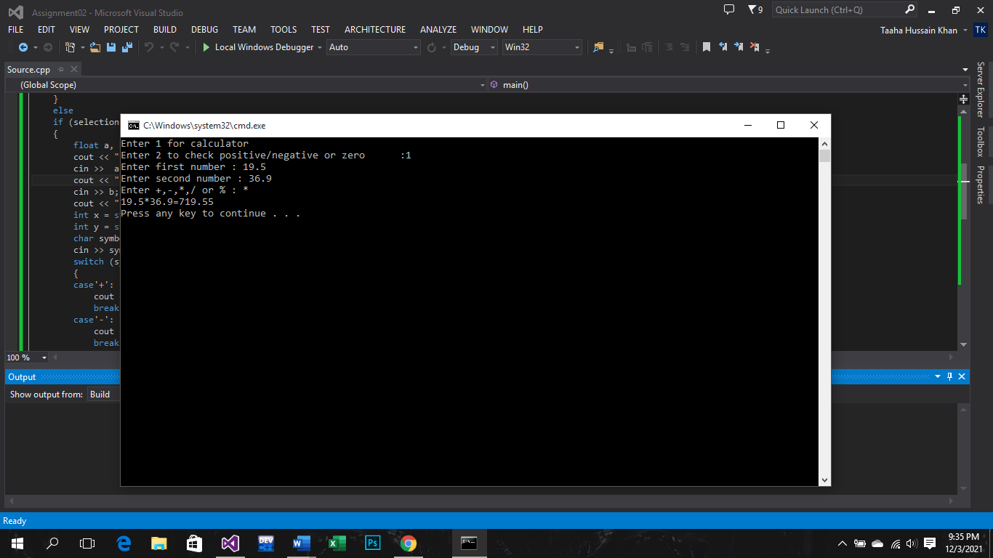

1. **For variable named *selection*, give input 1, than for variables named *a* and *b*, give any decimal value input. Than for variable named *symbol*, give input /.**

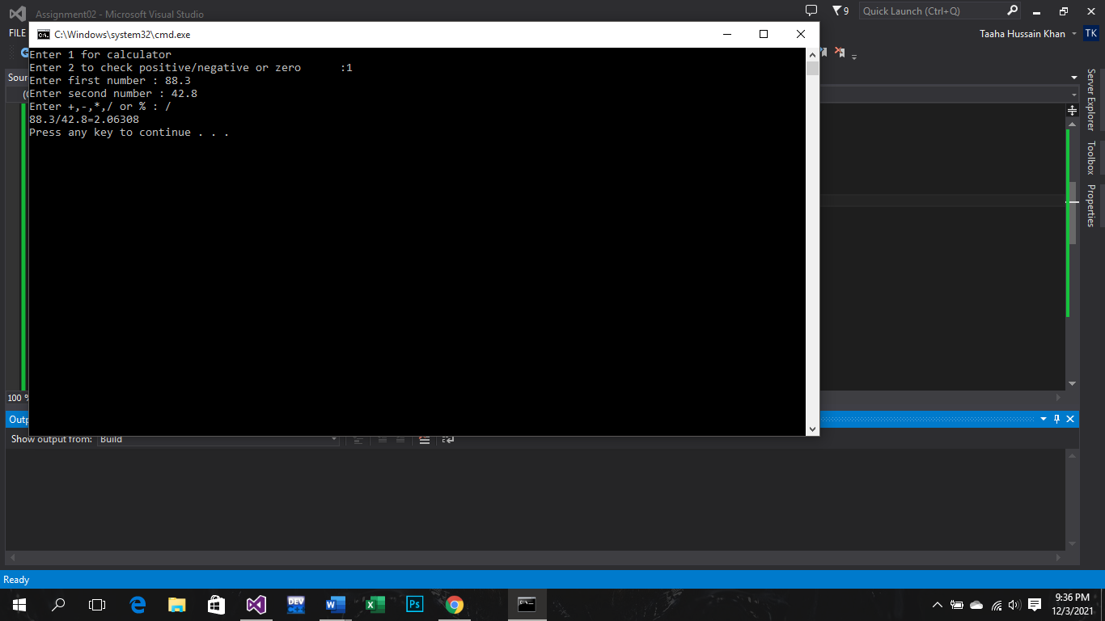

1. **For variable named *selection*, give input 1, than for variables named *a* and *b*, give any decimal value input. Than for variable named *symbol*, give input %.**

